

Tuduans
TUDU Character Development & Wiki

1. Overview
Tuduans are humanoid alien mascots and fictional characters created by TUDU Entertainment Inc. as part of the company's branding, storytelling, and community engagement strategy. Designed to be friendly, curious, and approachable, Tuduans represent exploration, connection, and real-world discovery.
Originally introduced as a marketing concept, Tuduans have grown into a broader narrative and outreach tool — with the potential to anchor a full cartoon series, social media presence, merchandise line, and the face of the TUDU Kids Foundation.
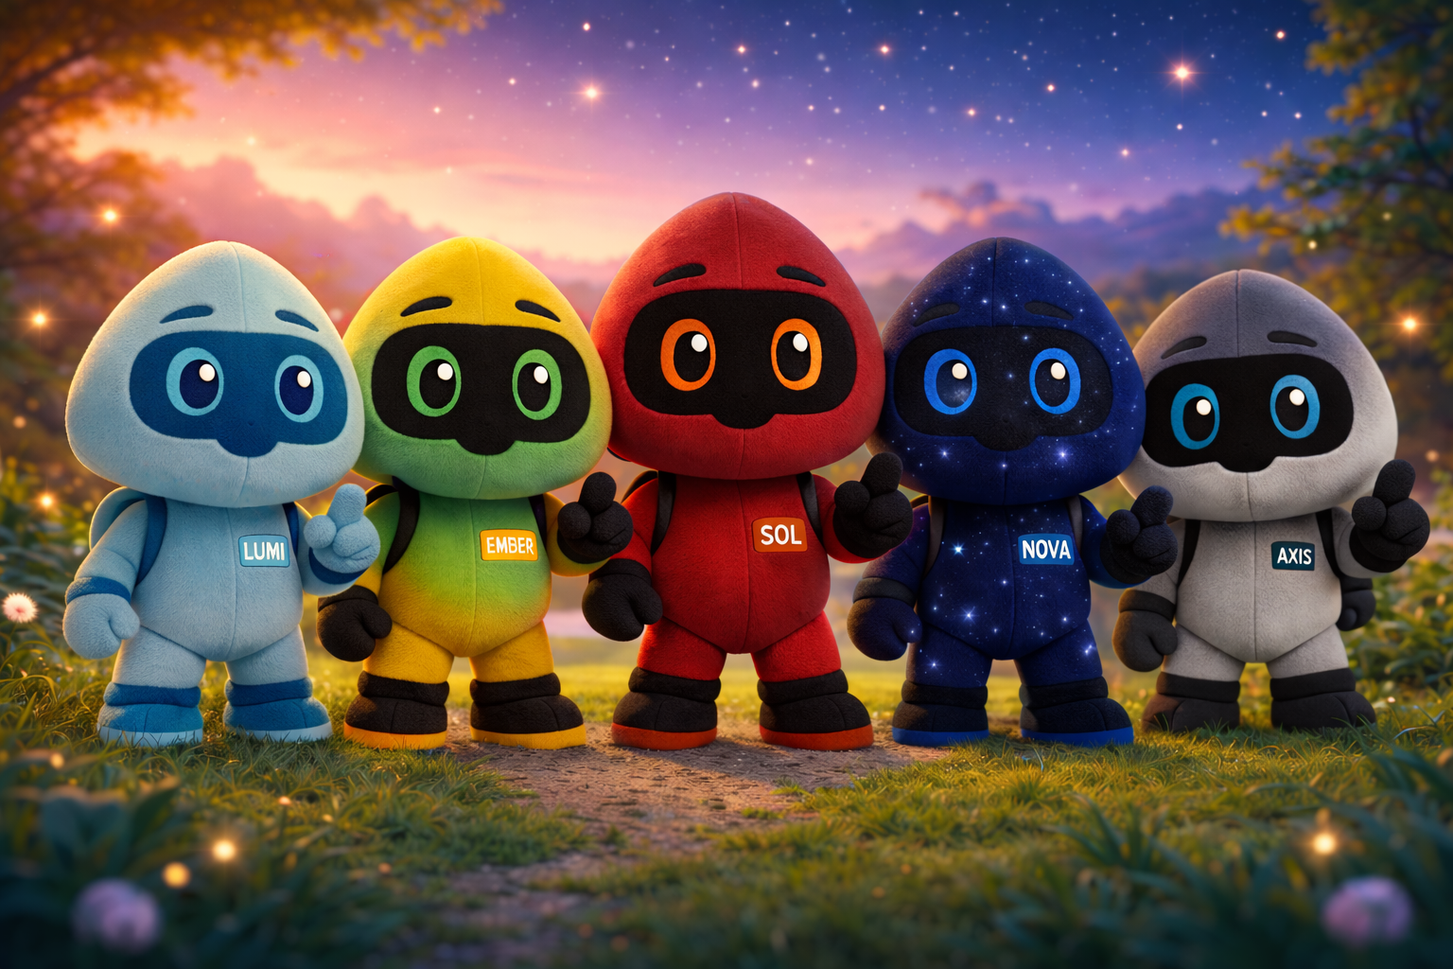
The five Tuduans: Lumi, Ember, Sol, Nova, and Axis

2. Concept and Creation
Tuduans were developed during the early design phase of the TUDU platform as a way to humanize the brand and reduce the perceived barrier between technology and real-world activity. The goal was a character concept that could appeal to both adults and children, while remaining flexible enough to grow alongside the platform.
Rather than acting as constant on-screen guides, Tuduans are intentionally designed to appear sparingly within the TUDU ecosystem. This limited presence reinforces their role as rare observers and gentle nudges toward exploration, rather than intrusive mascots or assistants.

3. Fictional Description
In the fictional universe associated with TUDU Entertainment, Tuduans are described as:
- Humanoid alien beings
- Naturally curious and exploratory
- Drawn to moments of shared experience and adventure
- Observers of human culture rather than rulers or invaders
Their design emphasizes soft features, expressive eyes, and a non-threatening silhouette, reinforcing approachability and emotional warmth. Each Tuduan carries its own color palette and visual motif, giving the group a distinct, collectible identity while remaining clearly part of one family.

4. The Five Tuduans
The current roster introduces five named Tuduans, each with a distinct color, visual motif, and personality. These are early character directions — bios below are a first pass meant to be refined as the lore develops.

Sol — The Spark
Color & Motif: Red, warm-toned, sun-inspired.
Sol is the group's bright, energetic center of gravity — the one who says "let's go" before anyone else has finished asking the question. Sol represents warmth, momentum, and the thrill of jumping into a new adventure without overthinking it.

Lumi — The Guide
Color & Motif: Light blue, soft and glowing.
Lumi is calm, gentle, and observant — the quiet voice that notices what others miss. Lumi represents clarity and light, often the one who helps a moment make sense or points the way forward without needing to lead loudly.

Ember — The Grower
Color & Motif: Yellow-green gradient, nature-inspired.
Despite the name, Ember's palette leans toward growth rather than fire — playful, curious, and always drawn to the outdoors. Ember represents discovery in the natural world: trails, parks, water, and the small wonders found outside.

Nova — The Dreamer
Color & Motif: Deep navy with a starfield pattern.
Nova is thoughtful and imaginative, associated with the night sky and big, ambitious dreams. Nova represents wonder and the pull toward the unknown — the character most likely to stare up at the stars and ask "what's out there?"

Axis — The Steady One
Color & Motif: Grey/silver with a frost and snowflake pattern.
Axis is grounded, dependable, and calm under pressure — the group's quiet center of balance, much like a planet's axis. Axis represents consistency and resilience, often associated with winter, ice, and remote, quiet places.
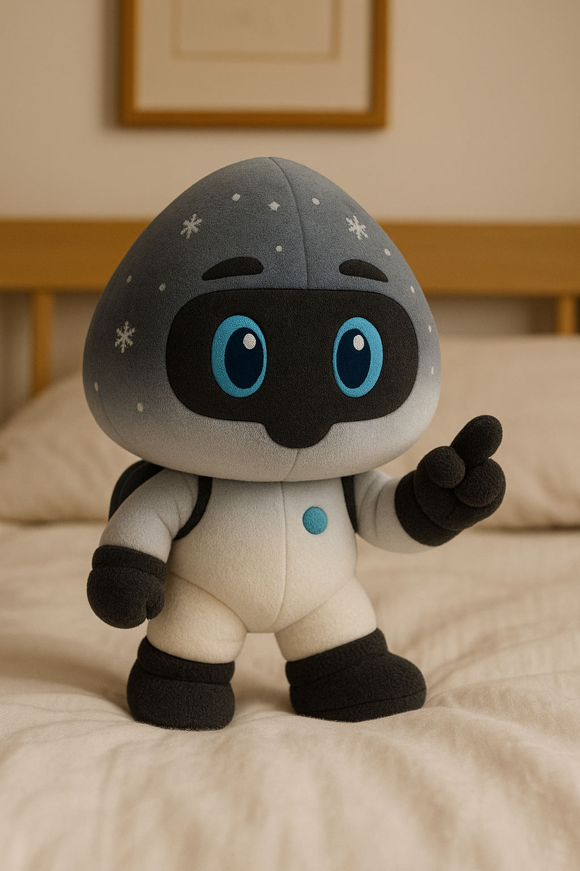
Axis — detailed character design, showing the frost/snowflake motif
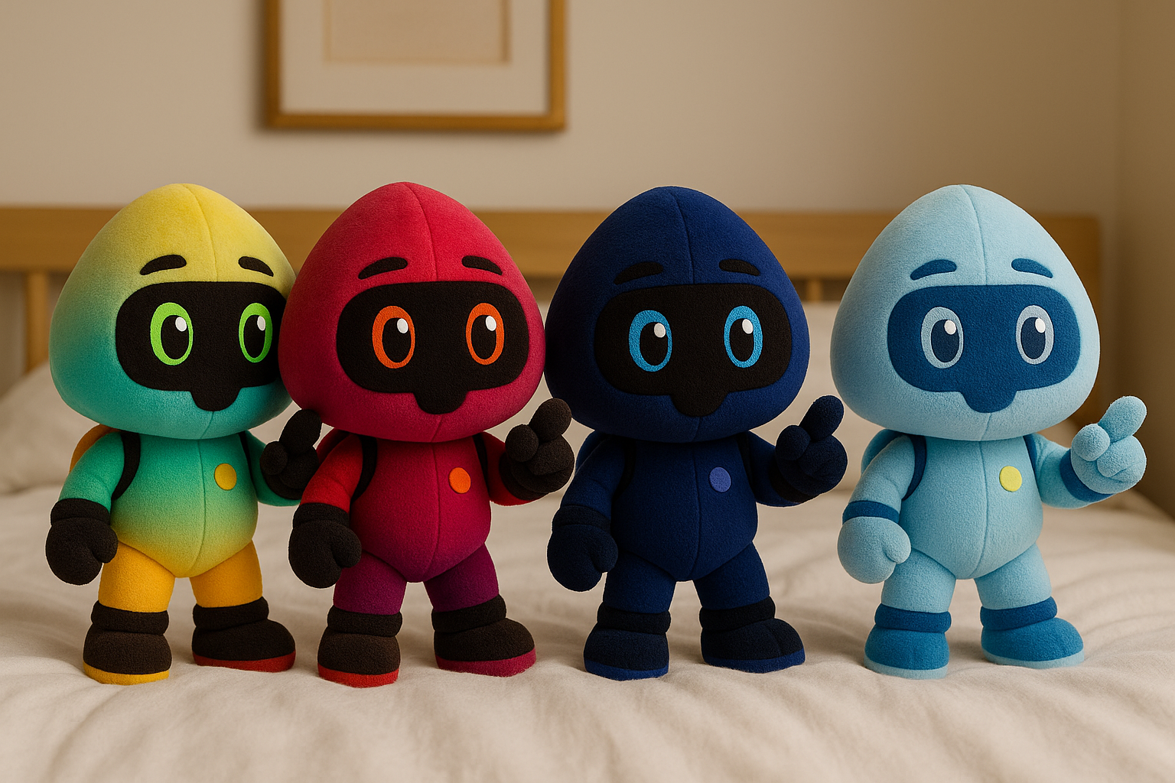
Ember, Sol, Nova, and Lumi — close-up character reference
Direction note: These are first-draft personalities based on color and visual motif alone. Recommend a dedicated lore session to lock in names-to-traits permanently, plus define relationships between characters (who's the leader, who bickers with whom, etc.) before scripting any video content.

5. Role Within the TUDU Platform
Within the TUDU ecosystem, Tuduans function as:
- Symbolic guides rather than constant UI elements
- Occasional visual markers tied to discovery, milestones, or special moments
- Brand ambassadors representing curiosity and movement beyond digital spaces
Their presence is deliberately restrained to avoid overwhelming users or turning the platform into a character-driven interface.

6. TUDU Kids Foundation Involvement
Tuduans are planned to play a central role in the TUDU Kids Foundation, helping underprivileged children experience real-world adventures and activities. In this context, Tuduans are envisioned as:
- Storytelling companions
- Symbols of hope, exploration, and possibility
- Characters that bridge entertainment with charitable outreach
This marks a shift from purely branding usage to narrative-driven social impact — the same five characters kids might recognize from a cartoon or a plushie could also be the ones welcoming them onto the Foundation bus.

7. Media & Content Vision
The long-term vision for Tuduans extends well beyond a static mascot, into a full media presence:
- A full YouTube cartoon series built around the five characters and their adventures.
- Dedicated social media pages for the Tuduans, separate from (but linked to) TUDU's main brand accounts.
- Tuduans as the recurring mascot presence for the TUDU Kids Foundation, appearing in tour content, signage, and materials.
- Potential crossover content with TUDU Crew, tying the characters into real-world event coverage.
Direction note: Decide on a content pipeline owner for the cartoon series — will this be produced in-house, outsourced to an animation studio, or built using AI-assisted animation tools? This decision significantly affects budget and timeline.

8. Merchandise and Media (Planned)
As of early 2026, Tuduans have not been widely commercialized. Planned and possible directions include:
- Plush toys (as shown in early character renders)
- Backpacks
- T-shirts and apparel
- 3D-printed collectible toys
- Illustrated media and children's books
- Digital storytelling and educational or adventure-themed content
Any such expansions are intended to remain secondary to the platform's core mission of encouraging real-world participation — merchandise supports the story, rather than becoming the point of it.
Direction note: Each character's color and motif (fire/sun, light, nature, stars, frost) lends itself naturally to themed merchandise collections or seasonal releases — worth considering as a launch strategy (e.g., release Sol and Ember first for a summer push, Axis for a winter collection).

9. Cultural Significance
Tuduans are designed to reflect the central philosophy of TUDU Entertainment: that technology should act as a gateway to shared human experiences rather than a replacement for them. By positioning the characters as observers and companions rather than protagonists, the brand emphasizes user agency and real-world action.

10. Next Steps
- Create full individual bios for each Tuduan (origin, personality quirks, catchphrases, relationships to one another).
- Define Tuduan lore — origin story, purpose, and how they came to observe/accompany humans.
- Develop plushie-ready character specs (exact colors, proportions, materials) for manufacturing.
- Write a full "Lore Codex" — a non-Wikipedia-style deep reference document — to support writers once video content begins.
- Map out how Tuduans tie into specific app moments, rewards, or milestones (e.g., a character appearing when a user hits a TUDU Miles milestone).

11. See Also
- TUDU Entertainment Inc.
- TUDU Kids Foundation
- TUDU Crew
- Brand mascots in digital platforms

